

 

**NATIONAL CONFERENCE ON COMMUNICATIONS (NCC): SILVER JUBILEE EDITION**

The **twenty-fifth** National Conference on Communications (NCC 2019) will be held at the Indian Institute of Science (IISc), Bangalore, during 20-23 February 2019. The conference will feature three symposia in the following areas.

**COMMUNICATIONS NETWORKS SIGNAL PROCESSING**

Previously unpublished contributions from a broad range of topics in these areas are solicited, including (but not limited to) the following:

|  |  |  |
| --- | --- | --- |
| Communication theory and systems  Information theory  Coding theory  Wireless communications  Optical communications  RF and microwave communications  Satellite communications  Cognitive radio  Energy harvesting and green communications  Machine learning for communications  5G and beyond communication systems  Quantum communications | Next generation networks  Optical networks and systems  Sensor networks  Ad hoc networks  Wireless and wireline networks  Security  Networks and services management  Performance analysis  Complex networks  Biological networks  Cyber-physical systems/IoT | Signal processing for communications  Image and video signal processing  Multimedia applications  DSP algorithms and architectures  Speech and audio processing  Biomedical applications  Language identification  Machine learning, pattern analysis, and classification  Large dimensional signal processing  Sparse signal processing  Graph signal processing |

Researchers working in emerging fields of these areas are encouraged to submit their original findings. Submitted papers should be 5 pages in length in standard IEEE conference format and will be peer-reviewed by experts in the field. Detailed information on paper submission, technical program, accommodation, tutorials, and travel will be posted on the conference website: <http://www.ncc.org.in/ncc2019/>

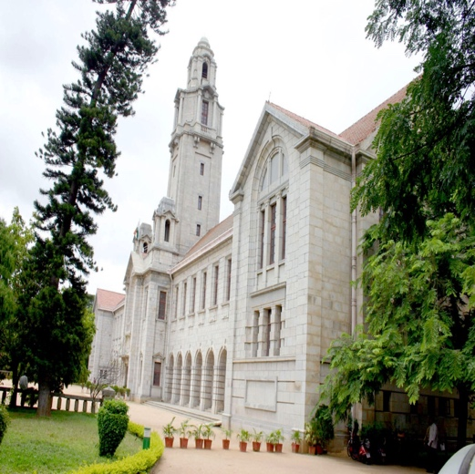**Key Dates:**

Paper submission deadline : 15 September 2018

Acceptance notification : 30 November 2018

For more information about the conference, please visit

<http://www.ncc.org.in/ncc2019/>

**General Chairs**

Neelesh B. Mehta (IISc Bangalore)

A. Chockalingam (IISc Bangalore)

**Technical Programme Committee Chairs**

Chandra R. Murthy (IISc Bangalore)

Navin Kashyap (IISc Bangalore)

Dilip Krishnaswamy (Reliance Jio)